Genuine yamaha painted panels
come in white, black, light blue, orange and yellow.
consists of 1 front fairing panel and 2 rear/sides.
price $150 plus $50 EMS shipping

Genuine yamaha BW'S vertical light conversion
Kit includes genuine yamaha light fairing, headlight, auxillary light and top fairing.
price $110, shipping is an additional $10 if ordered together, otherwise $39 by itself
I can supply with a carbon or chrome top fairing for an extra $10
multi direction, ultra bright LED auxillary light for $20, in a choice of white, blue or red.
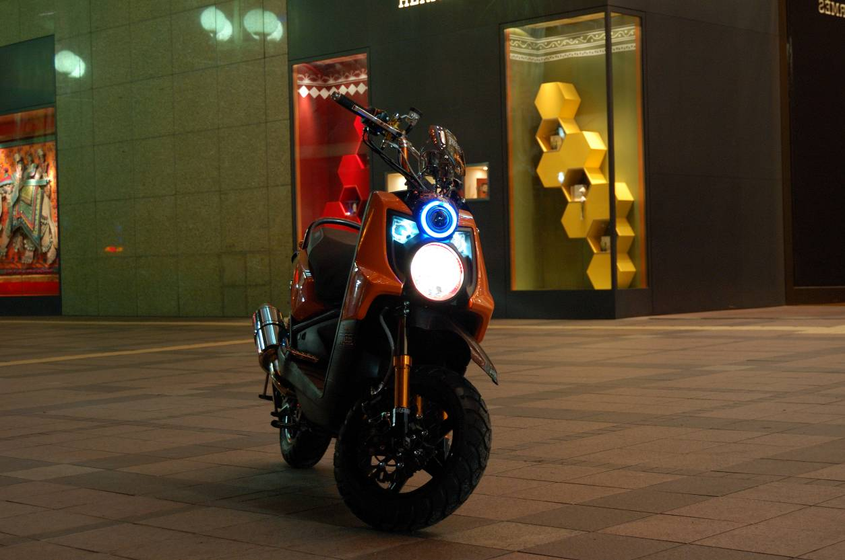

Carbon look transmission and airbox cover
This is painted by hand to order using genuine yamaha parts.
it does look very authentic and i still dont know how they do it!
Price $85 plus $30 shipping
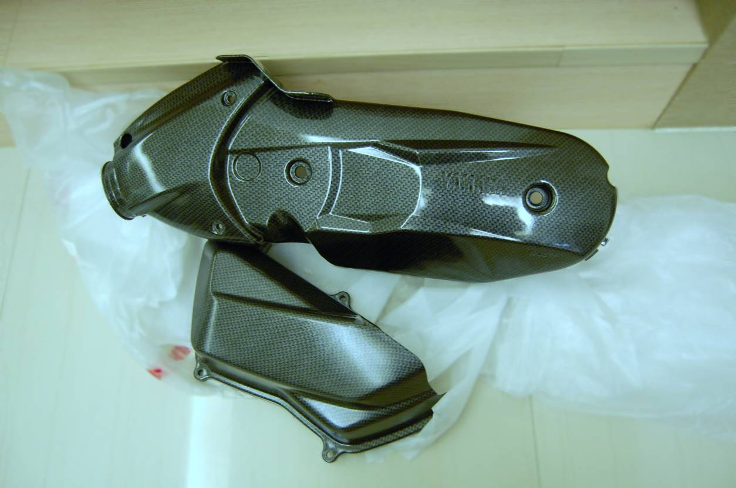

HID twin light conversion for US ZUMA 125
This is for a set of H4 35w 6000k HID lights, not some cheap Chinese knock offs, but quality ballasts and bulbs made in Taiwan, you will require a special regulator and cables which are also supplied.
Price $190 plus $50 shipping

LED rear lights
Silver when off, red when on!.
very bright and look really cool, they are plug and play. (they are not supplied with chrome as pictured)
Price $80 plus $35 shipping
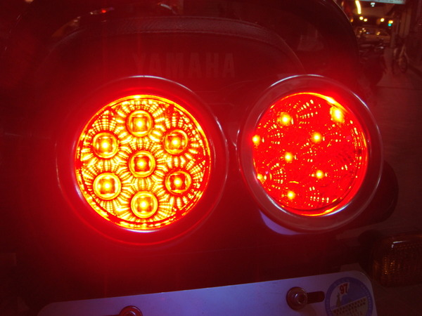

ACCEL handlebars
Look cool and come with a nice crossbrace and made with high quality CNC alloy (stock is steel).
6 colours to choose, look at the pic and decide, same height as stock.
Price $60 plus $25 shipping
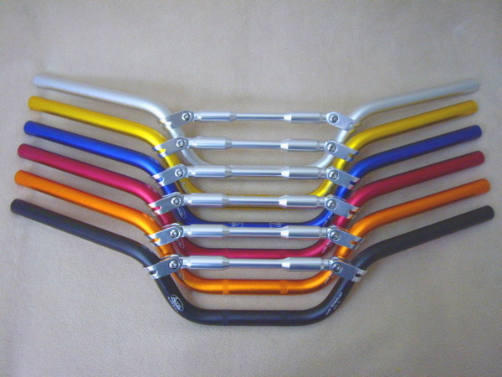

KOSO GTR mirrors
Wow, simply awesome, have a look!.
8mm or 10mm, so any scooter or superbike can have them!
Price $45 plus $30 shipping 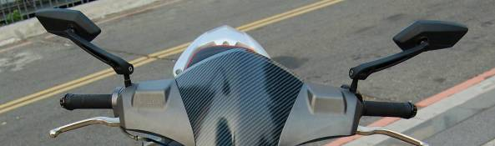
RPM CNC alloy sidestand
Looks great and saves weight!
Price $45 plus $28 shipping
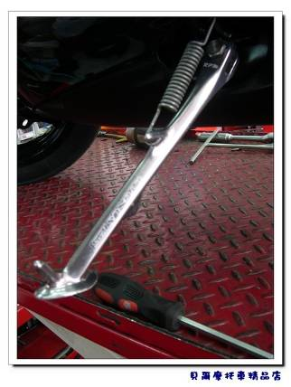
Genuine Alloy rear footrest
bolts on and looks neat!
$40 plus $25 shipping
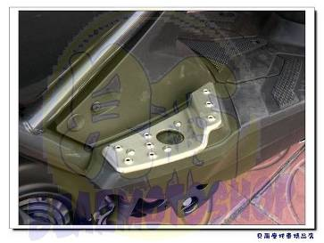
Genuine rear rack
Not aftermarket but genuine yamaha!.
$50 plus $45 shipping
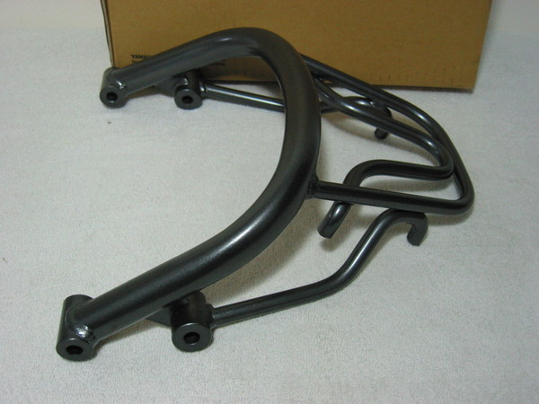
Genuine chrome bellypan
bolts behind the front wheel and looks sweet, again genuine yamaha!.
$40 plus $25 shipping
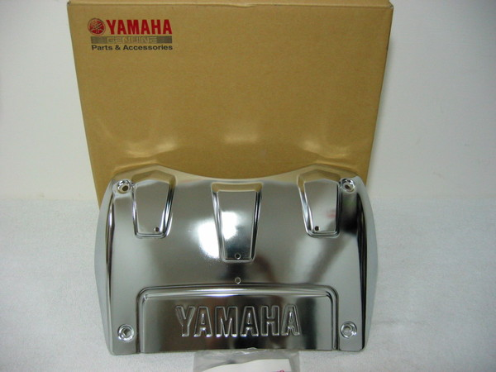
Genuine handguards
Bolts onto standard switch gear, Genuine part.
black or white
Price $30 plus $25 shipping
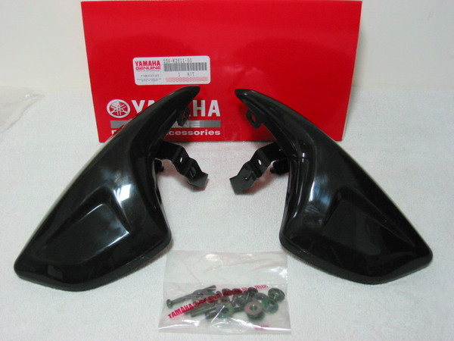
Swingarm cup
Bolts on the rear rightside axle, just looks cool!
silver or gold
Price $30 plus $22 shipping

RRGS Entry level rear shock
Remember price is for 2!
SPRINGS:
white
black
yellow
red
BODY:
Black
gold
silver
PRELOAD ADJUSTMENT:
gold
silver
purple
blue
red
Price: $365 plus $65 shipping
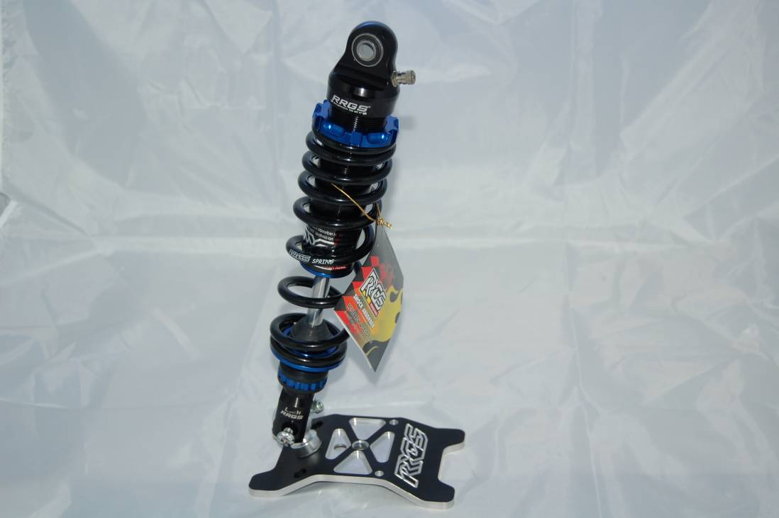
RRGS pro level rear shock
As above but with an external resevior and special nitrate coating to ensure smooth movement.
Same colour choices
Price: $550 plus $75 shipping
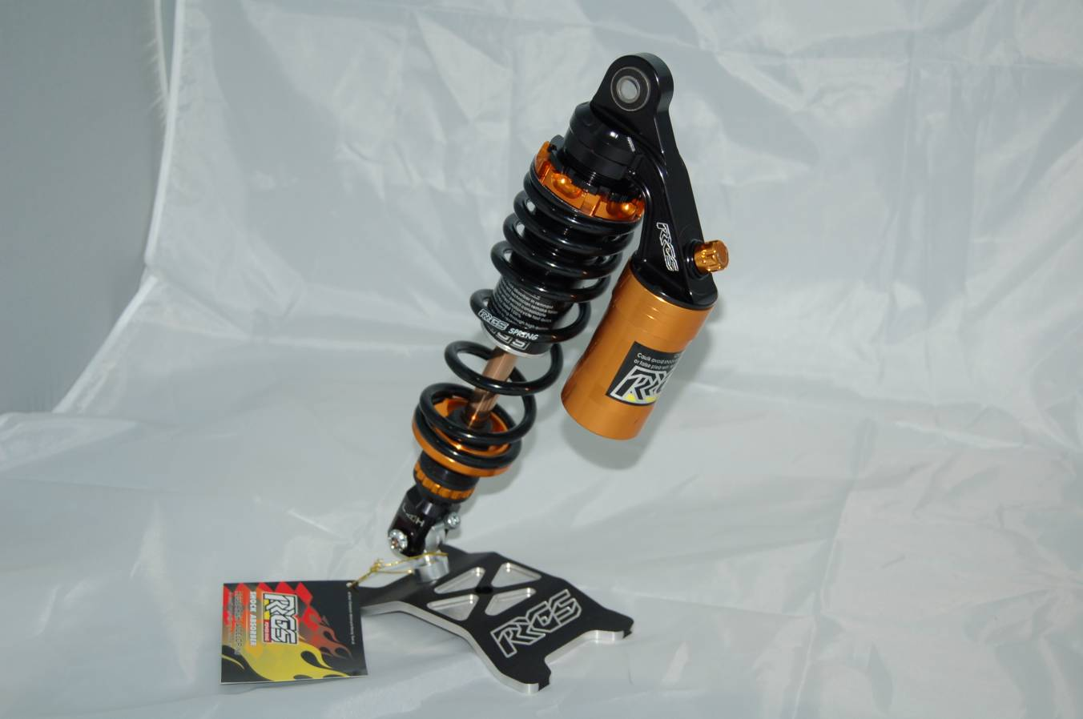

RRGS Front forks
FORK BOTTOMS:
silver
black
FORK LEGS:
gold
silver
FORK STANCHIONS:
gold
multi coloured
blue
Price: $380 plus $70 shipping
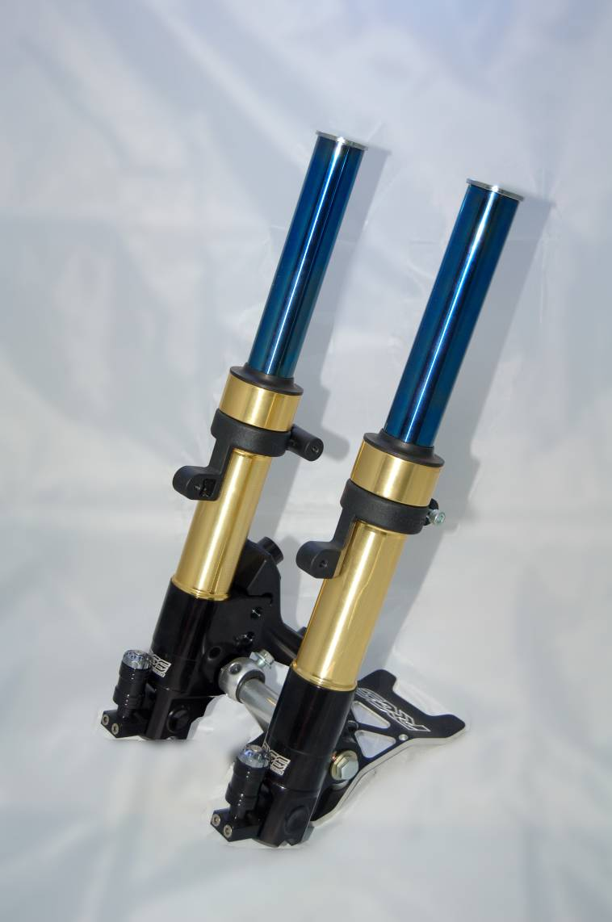
RRGS Radial brake conversion
You will need a 260mm disc and I would recommend a stainless steel hose, which are extra.
Come in polished silver or black
Price: $160 plus $45 shipping
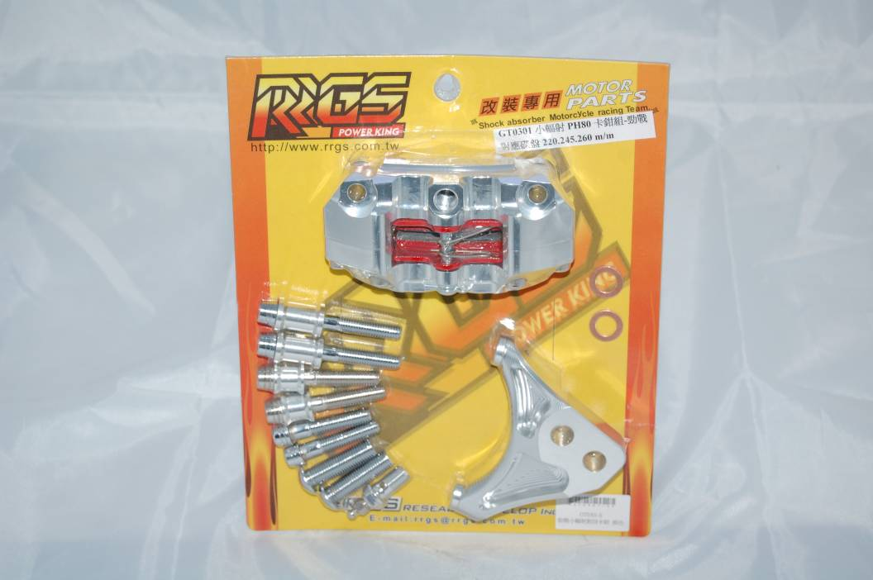
RRGS 260mm floating disc
Nice and sexy, will require a big brake kit.
Price: $150 plus $35 shipping
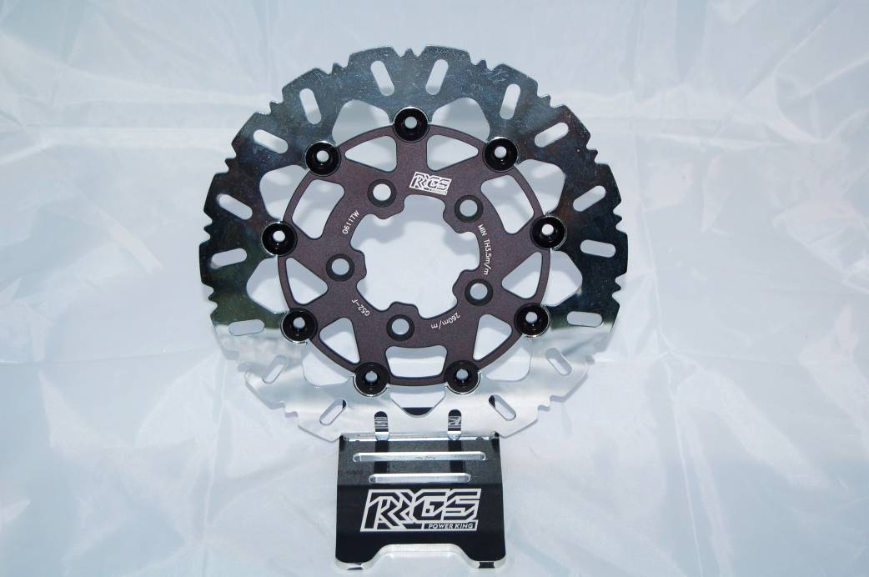
RRGS steel braided hose
Goes with all the above, looks trick and improves brake feeling.
Price: $40 plus $20 shipping
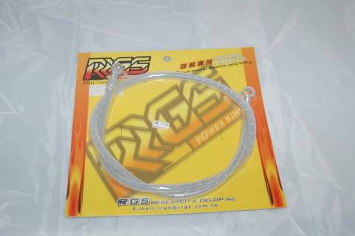
RPM radial brake lever
Silver or gold, significantly increases stopping power and brake feel.
Price: $160 plus $25 shipping
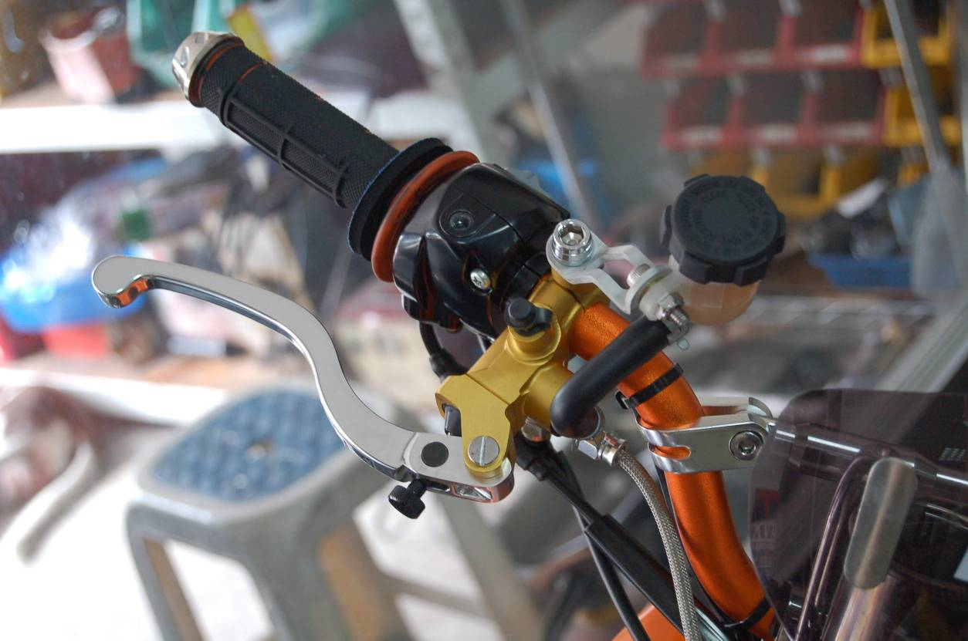
CNC alloy swing arm
Comes in any of the shown colours.
Price: $200 plus $55 shipping
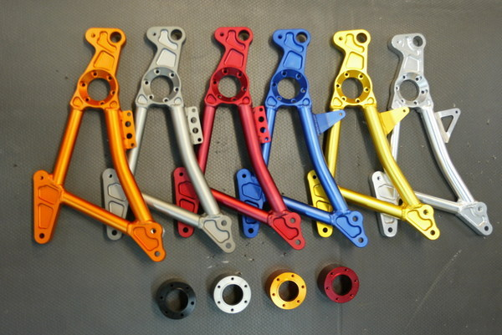
KOSO race clutch
Price: $130 plus $40 shipping
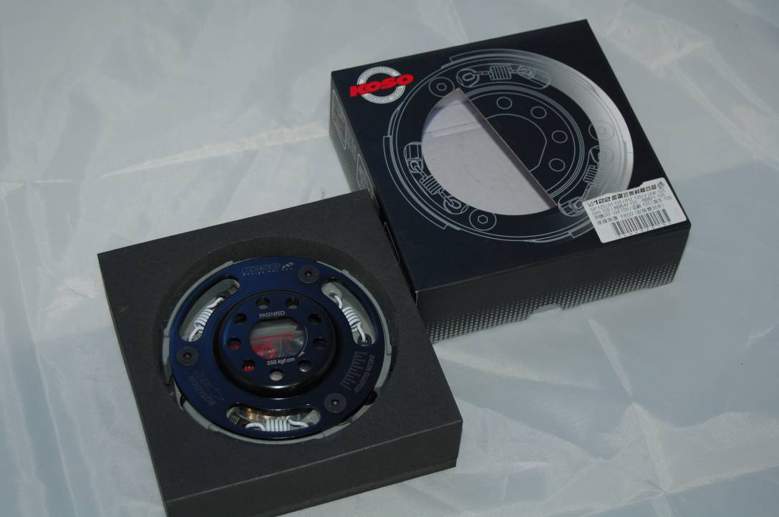
RRGS 155cc oil cooled kit
58.5mm piston, just drops right in, no casework required
Price: $200 plus $55 shipping
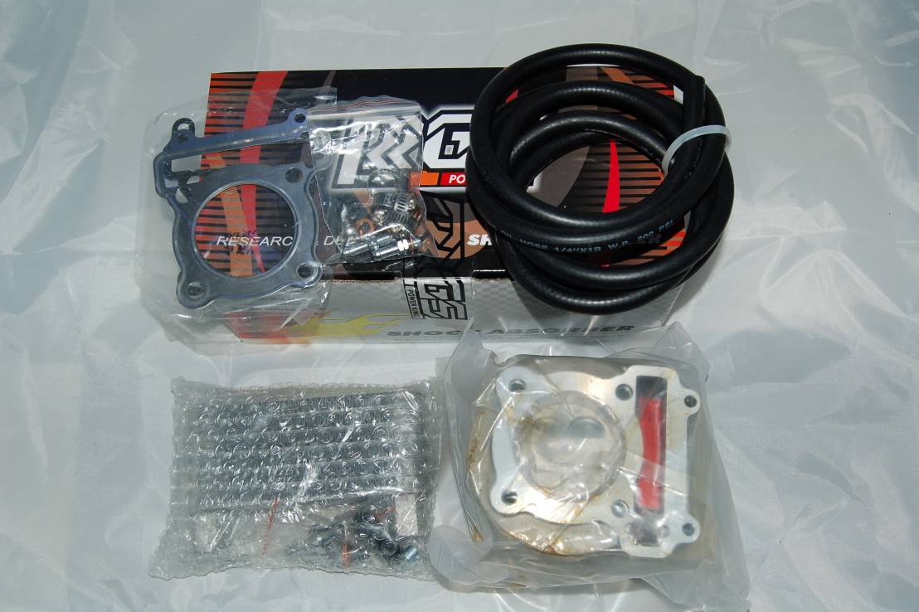
RRGS CNC 62mm crankshaft
420 pulls, just drops in place, no machining required.
Price: $270 plus $55 shipping
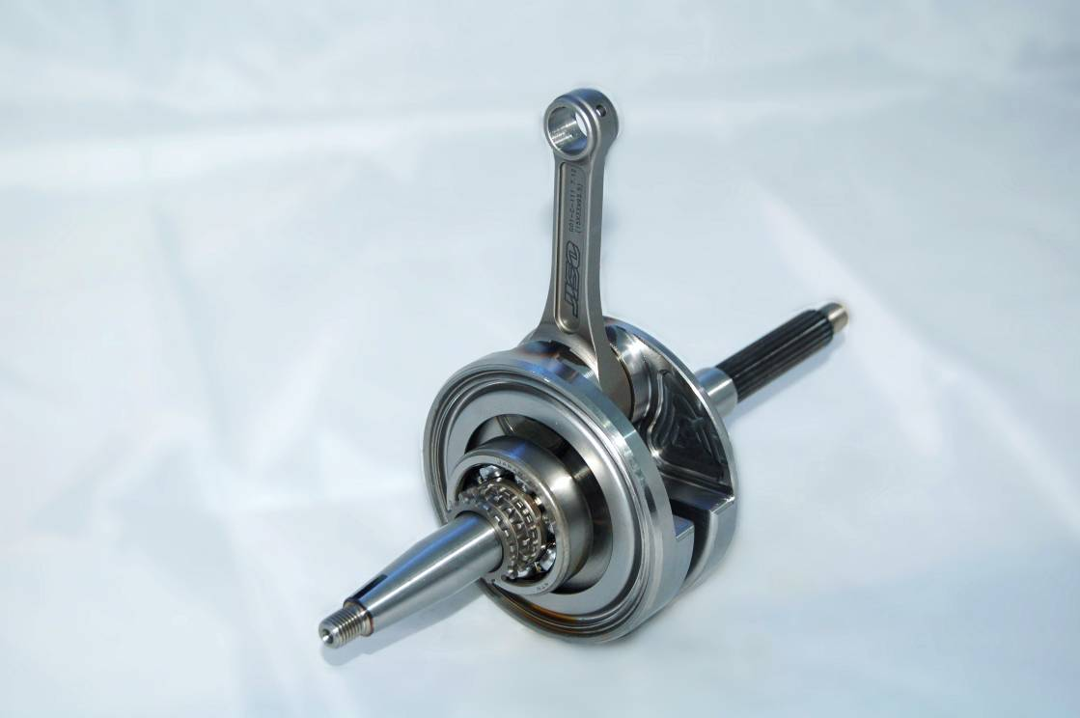
RRGS CNC 68mm crankshaft
1010 pulls, requires case work, this is the best all round crankshaft on the market, serious power increases with this crank!.
Price: $300 Plus $55

RRGS 192cc oil cooled kit
65mm piston, can be used with stock crank for 192cc or with a stroker kit listed above.
Price: $250 plus $55 shipping

RRGS 254cc conversion kit
Super strong and reliable day to day, this kit makes proven reliable power with top speeds in excess of 90mph and monster torque at any speed.
Included in the kit:
RRGS big valve top end
RRGS 69mm oil cooled ultra lightweight piston kit
RRGS 68mm CNC crankshaft
KEIHIN PE30 flat side carburettor
RRGS manifold
RRGS quick action throttle
RRGS throttle cable
Stronger starter motor
Unrestricted Cygnus CDI
This will require case work in order to fit the piston and crank, you will also be required to do all jetting work.
Price: $1400 plus $110 shipping

RRGS 277cc conversion kit
As above but includes a 72mm piston kit, price is additional to above.
Price: $100 shipping as above

Coming soon
RRGS 73mm crankshaft, combined with the 72mm piston kit gives 307cc!

Razer exhaust system
Price: $175 plus $75 shipping
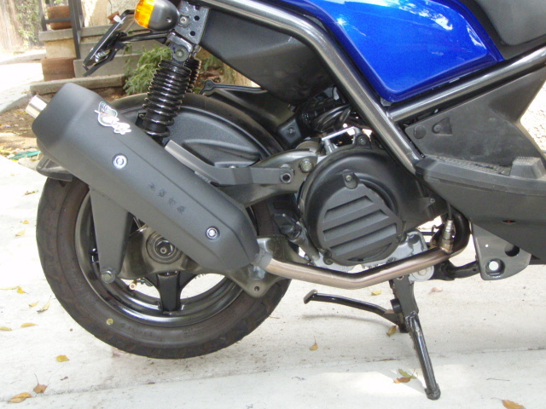

Custom made exhaust system
Prices vary depending on material chosen, you can have carbon, titanium or stainless steel in polished or black.
Takes just over a week to manufacture, you choose the style, noise and length.
Price: $250-$350 plus $75 shipping
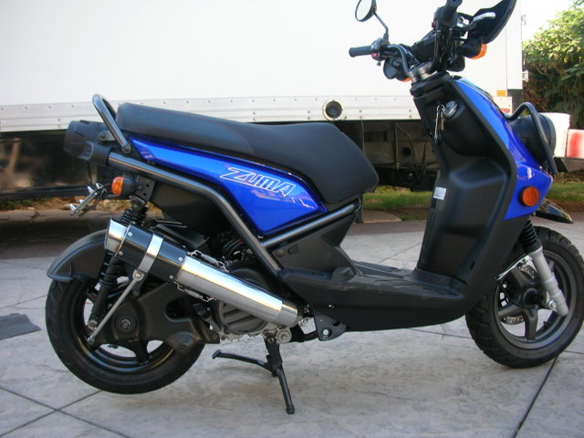
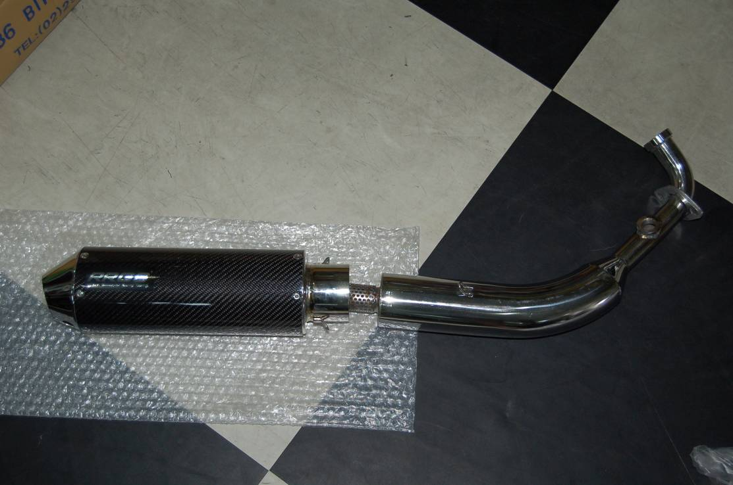
RRGS Transmission kit
Price: $120 plus $30 postage
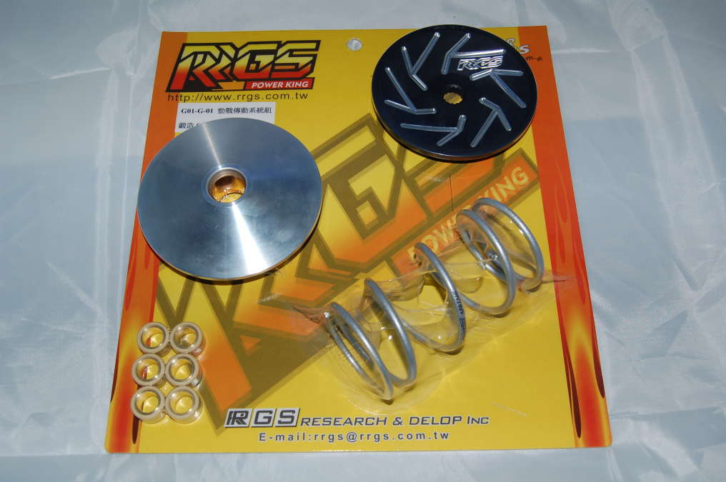
RRGS Clutch bell
Price: $45 plus $38 postage
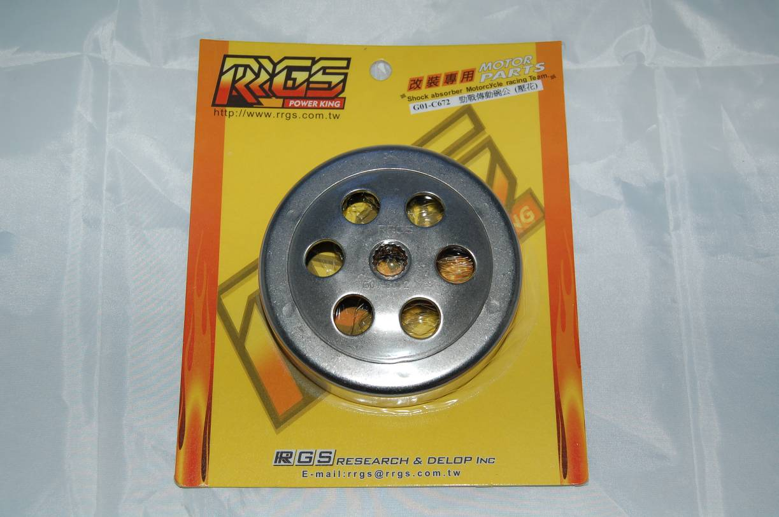
RRGS Frontend Conversion
Includes:
Forks
Radial 4 piston caliper
Stainless steel hose
260mm floating disc
Required spacers
Price: $550 plus $90 shipping


